User research

Goal 1

Research method 2

Interview questions 2

Screening 2

Targeting 2

Validating 2

Results 2

Results from students and teachers in TQ4.2 3

Results from vegan forum 6

Analysis 8

TQ4.2 8

Facebook 8

Conclusion 8

# Goal

The goal of this user research was to answer the two underlying questions by asking them to our target audience: people with diets or allergies.

* Would people with allergies or specific diets use an app that helps them identify and select products that would fit their restrictions?
* Would people shop more at grocery stores that provide such a service?

# Research method

The research method used was: **Field: Interview**

# Interview questions

The interview questions are divided into 'screening', 'targeting', and 'validating'.

## Screening

By using the screening questions, the people that are not allergic or following a diet are filtered out as they are not part of our target audience.

1. Do you have any food allergies/dietary restrictions or specific eating preferences?
2. How did you learn about your diet/allergy?

## Targeting

The targeting questions provide information about the current shopping situation and opinions from the interviewee.

1. Do you do your own groceries? How do you know what products to purchase?
2. Which supermarket do you shop at the most?
3. Does it accommodate your situation?

## Validating

Lastly, the validating questions will answer our main questions and give the interviewee the opportunity to add additional ideas.

1. Would you use an app that helps you select products that fit your pre-set criteria?
2. Let’s say supermarket X has such an app; would it encourage you to shop there more?

(Explain concept)

1. What other features would you find useful?

# Results

The interview was conducted in person by asking students and teachers in the TQ4.2 building and by posting the questions in a vegan community on Facebook.

## Results from students and teachers in TQ4.2

1. **Do you have any food allergies/dietary restrictions or specific eating preferences?**

Whole-food plant based

1. **How did you learn about your diet/allergy?**

Books, scientific papers, and movies

1. **Do you do your own groceries? How do you know what products to purchase?**

Yes, knows what he can eat and looks at packaging

1. **Which supermarket do you shop at the most?**

Jumbo

1. **Does it accommodate your situation?**

Yes

1. **Would you use an app that helps you select products that fit your pre-set criteria?**

Depends on the app, but yes

1. **Let’s say supermarket X has such an app; would it encourage you to shop there more?**

Yes

1. **What other features would you find useful?**

Won't use the ‘checker’ feature, but is interested in recommendations

_____________________________________________________________________________________

1. **Do you have any food allergies/dietary restrictions or specific eating preferences?**

Lactose intolerant

1. **How did you learn about your diet/allergy?**

Doctor validated

1. **Do you do your own groceries? How do you know what products to purchase?**

Yes, milk substitutes

1. **Which supermarket do you shop at the most?**

Aldi

1. **Does it accommodate your situation?**

Kind of

1. **Would you use an app that helps you select products that fit your pre-set criteria?**

Yes

1. **Let’s say supermarket X has such an app; would it encourage you to shop there more?**

Yeah definitely

1. **What other features would you find useful?**

Discounts on milk substitutes

_____________________________________________________________________________________

1. **Do you have any food allergies/dietary restrictions or specific eating preferences?**

Lactose

1. **How did you learn about your diet/allergy?**

Trial and error

1. **Do you do your own groceries? How do you know what products to purchase?**

Yes, labels and packaging

1. **Which supermarket do you shop at the most?**

Albert Heijn

1. **Does it accommodate your situation?**

Yes, vegan products

1. **Would you use an app that helps you select products that fit your pre-set criteria?**

Yes, probably

1. **Let’s say supermarket X has such an app; would it encourage you to shop there more?**

Yes

1. **What other features would you find useful?**

Other diets

_____________________________________________________________________________________

1. **Do you have any food allergies/dietary restrictions or specific eating preferences?**

Sesame seeds and walnuts

1. **How did you learn about your diet/allergy?**

Swollen eye, walnuts: just can't eat

1. **Do you do your own groceries? How do you know what products to purchase?**

Partly. Sesame seeds aren't dangerous in small amounts so shortly looking at ingredients

1. **Which supermarket do you shop at the most?**

Albert Heijn

1. **Does it accommodate your situation?**

Yes, lots of food for no sesame, seeds. But no solution online

1. **Would you use an app that helps you select products that fit your pre-set criteria?**

Yes, that would be awesome

1. **Let’s say supermarket X has such an app; would it encourage you to shop there more?**

Probably

1. **What other features would you find useful?**

-

____________________________________________________________________________

1. **Do you have any food allergies/dietary restrictions or specific eating preferences?**

Lactose intolerance

1. **How did you learn about your diet/allergy?**

My body told me

1. **Do you do your own groceries? How do you know what products to purchase?**

Not really, looks at packaging

1. **Which supermarket do you shop at the most?**

Jumbo

1. **Does it accommodate your situation?**

Kind of

1. **Would you use an app that helps you select products that fit your pre-set criteria?**

Probably

1. **Let’s say supermarket X has such an app; would it encourage you to shop there more?**

Not sure

1. **What other features would you find useful?**

-

_____________________________________________________________________________

1. **Do you have any food allergies/dietary restrictions or specific eating preferences?**

Yes, vegan.

1. **How did you learn about your diet/allergy?**

Research, doctors, documentaries.

1. **Do you do your own groceries? How do you know what products to purchase?**

Yes, mostly. Read the labels.

1. **Which supermarket do you shop at the most?**

Lidl, Albert Heijn sometimes.

1. **Does it accommodate your situation?**

A bit, I like the discounts in Lidl and vegan options

1. **Would you use an app that helps you select products that fit your pre-set criteria?**

Yes

1. **Let’s say supermarket X has such an app; would it encourage you to shop there more?**

Perhaps

1. **What other features would you find useful?**

Benefits of my choices, discounts for frequently bought products, recommendations of new related produce, simple recipe ideas

## Results From Vegan Forum

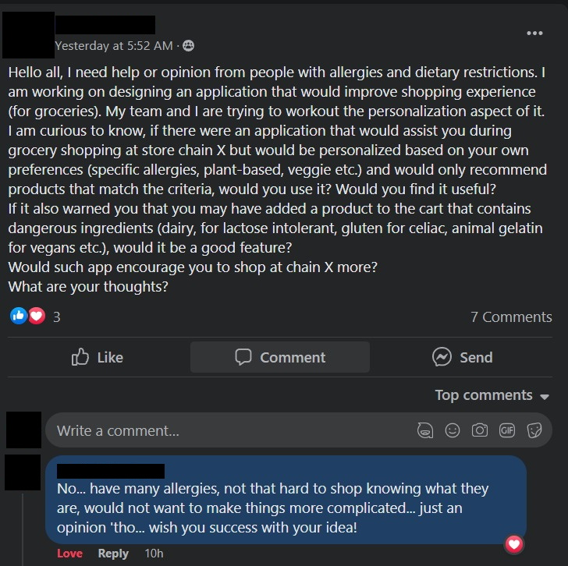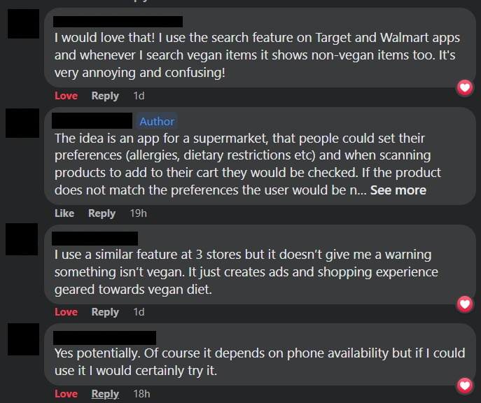

# Analysis

## TQ4.2

Out of all the people asked in TQ4.2, four had an allergy or intolerance, and two were following a diet.

Of the four with allergies and intolerances, everyone said they would most likely use an app that helped them identify the (to them) 'harmful' ingredients in certain products. The person that was following a plant based and whole foods diet would not use an app for identifying ingredients but would like recommendations based on the diet. Lastly, the vegan interviewee would use an app that helps with finding and selecting vegan products.

Four out of the six interviewees would shop more at grocery stores that offer help in identifying and selecting products that match their diets and allergies. The remaining two would maybe do that, depending on some other aspects.

## Facebook

Of the four that responded on the post on Facebook, three reacted positively on the concept, the fourth person did not need an app to help with identifying and selecting products.

# Conclusion

8 out of 10 interviewees would probably use an app to help them identify and select products that match their diets and allergies. The remaining two were less impressed, but one of them would like to receive recommendations based on his diet.

Moreover, 4 out of 6 would shop more at grocery stores that provide such services, and the remaining two would maybe do so.